LAST CHANCE ANIMAL RESCUE, INC.
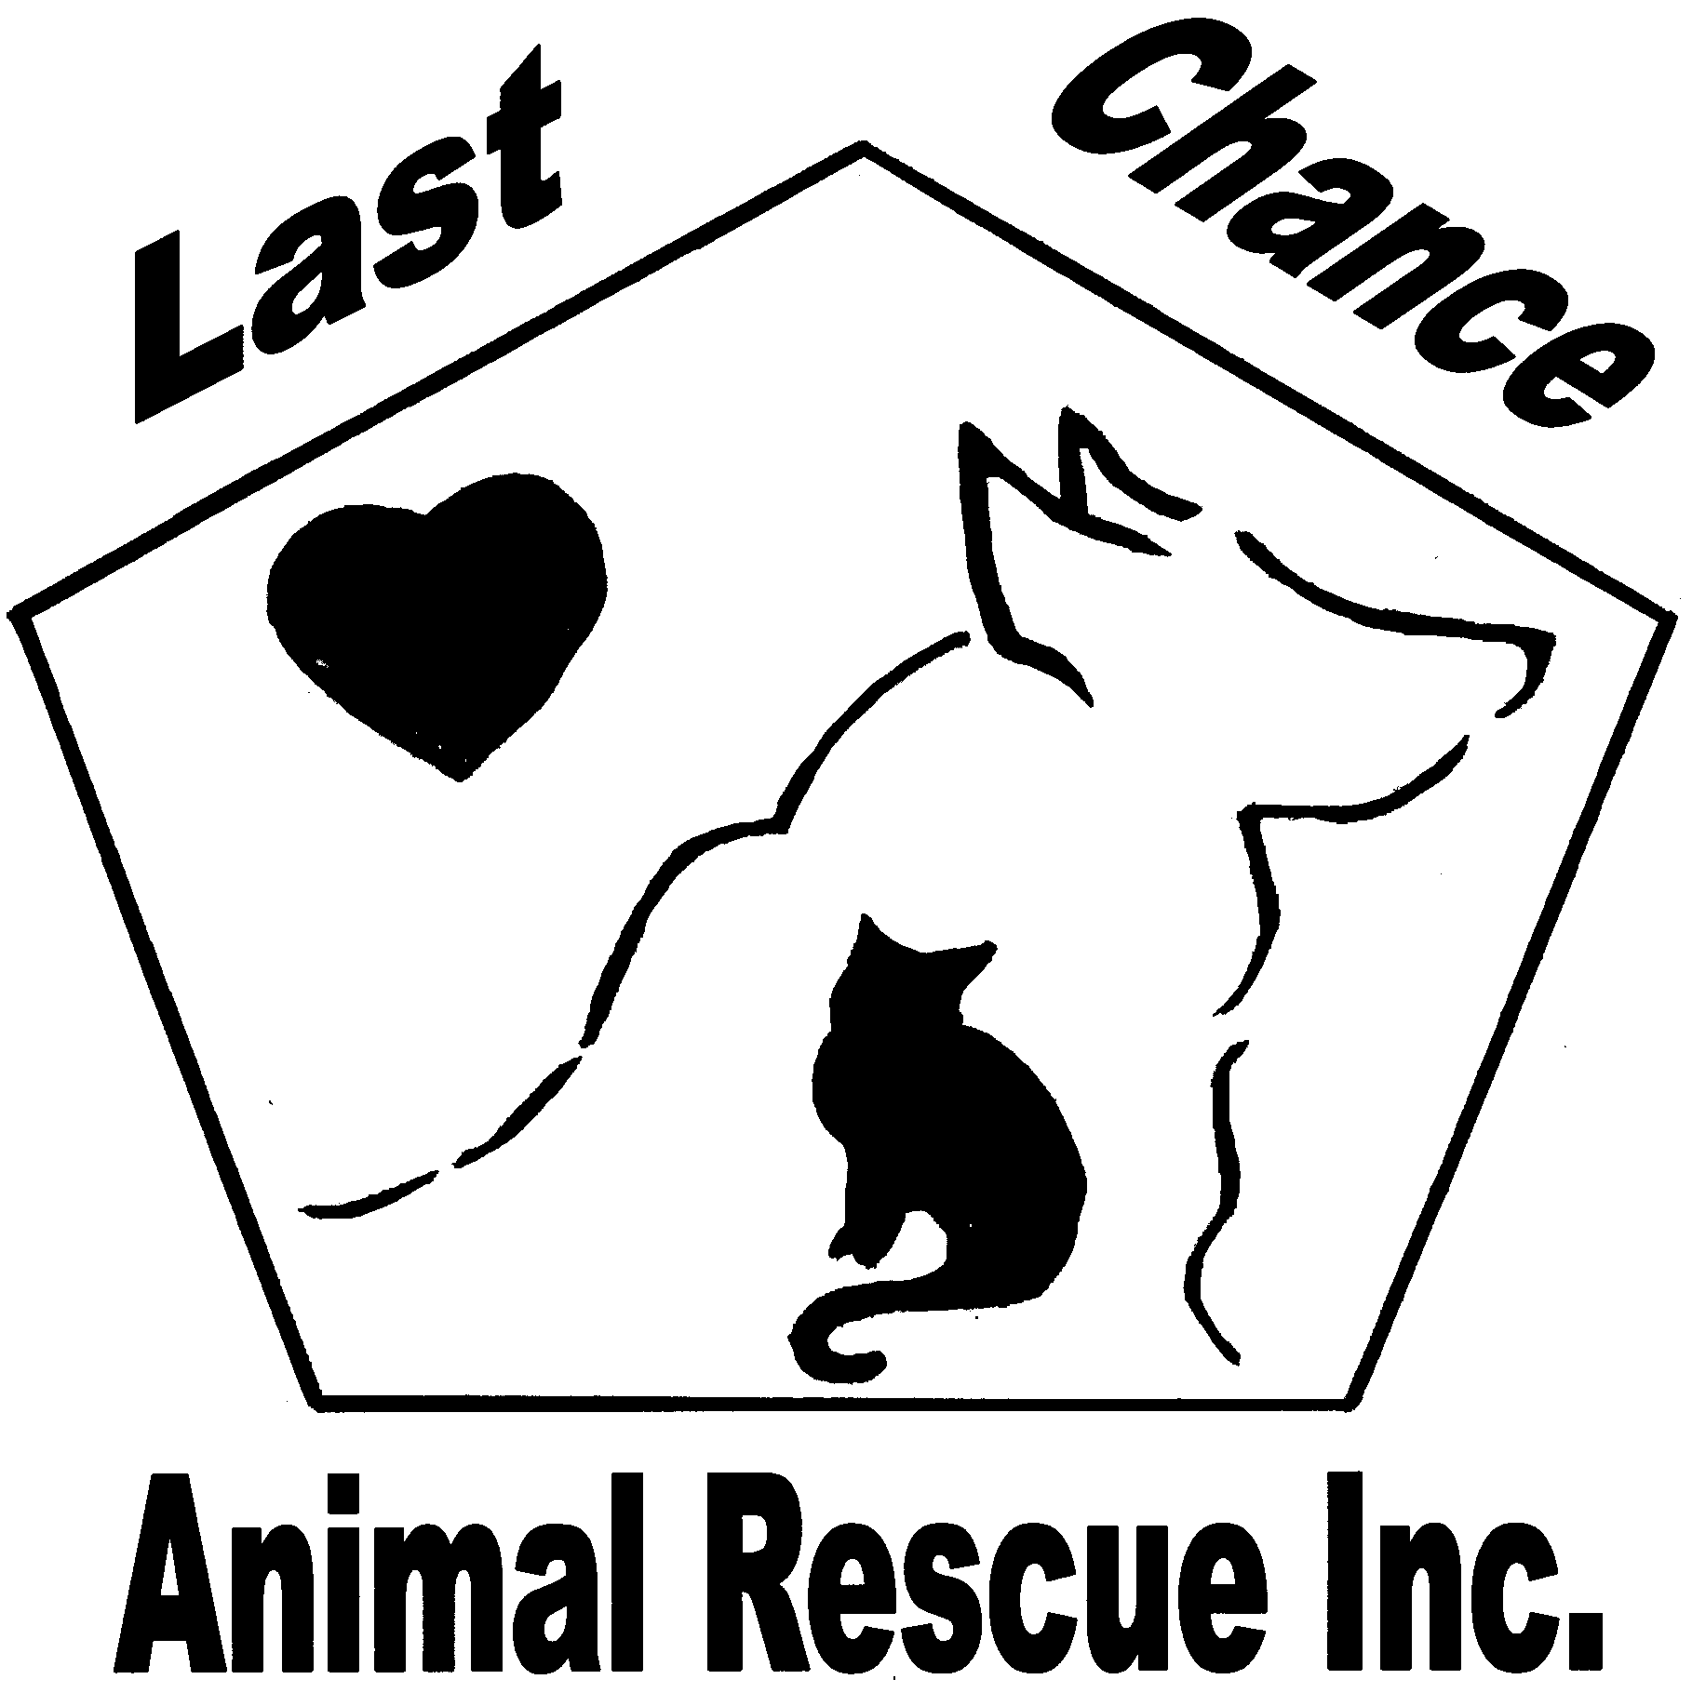
8500 Bensville Road, Waldorf, MD 20603
OFFICE: 301-274-9409 EMERGENCY CELL: 301-848-1956
www.lastchanceanimalrescue.org email: volunteer@lastchanceanimalrescue.org

VOLUNTEER AGREEMENT
As a volunteer for Last Chance Animal Rescue, Inc. (LCAR) I understand that the health and welfare of animals are our priority so I promise to abide by the following rules and regulations:
- I understand I represent LCAR while volunteering and will follow all guidelines expressed by LCAR and Petco.
- All kitties in the Luv-a-pet center are healthy to the best of our knowledge and vaccinated in accordance with Petco protocol and applicable state and local laws. If a kitty becomes sick or aggressive inform the manager on duty immediately (make sure you reference their four digit file number). You may call either of the numbers above and inform LCAR. Do not medicate cats in the luv-a-pet center, they are to be returned to LCAR where they will be cared for until they are healthy and available for adoption.
- Cats are not to be “held” for adoption. If a cat is in the store it is available for the first eligible new pet parent.
When performing an adoption:
- We must never discriminate against a potential adopter for any reason.
- Make sure you have read and understand the LCAR cat adoption contract in its entirety.
- Make sure the new pet parent has read, understands and agrees to the contract in its entirety and has completed all of the information requested LEGIBLY.
- Do not modify or allow a new pet parent to modify the LCAR contract in any way.
- Educate all potential adopters, even those who may be denied.
- It is not our policy to do home visits as part of pre-adoption approval, however, we do reserve the right to perform visits if deemed necessary prior to adoption.
- Never dispense veterinary advice pre or post adoption. Refer the new pet parent to their primary care veterinarian.
- There are no discounts of any kind given at any time.
While attending to the Luv-a-Pet center and kitties therein:
- Petco supplies food, litter (non-scoopable), litter boxes, bowls, paper towels, cleaning supplies, etc… NEVER take products or supplies from the store shelves unless specifically directed to by a store manager. There is a sticker (STORE USE) that should be used on all products in the LAP center.
- We do not utilize a donation jar. If someone would like to make a monetary donation to our organization please refer them to our website. We have a “Donate Now” feature that makes it very easy for one to donate using their credit card or checking account.
- Never directly or indirectly disparage Petco, or any Petco products, services, associates or the activities or reputations of any other organizations participating in the Adoptions Program.
- If ever there is an issue with Petco please contact Cindy Sharpley. If necessary a meeting with the appropriate managers will be arranged. Never go directly to corporate. We have an open door policy to all volunteers.
- The Luv-a-Pet center must be cleaned and maintained in accordance with LCAR and Petco regulations to prevent the spread of communicable diseases, viruses and parasites (see instructions on cleaning for more details).
- Never let a cat come in contact with another cat unless they are in the same litter. NEVER, EVER let kitties play together (EVER, EVER).
- Never put cats in a cage together unless they are littermates or have come to the store as cage mates.
- Do not accept surrendered or abandoned pets. Refer to the office number. Only cats checked in with an LCAR file number are allowed in the LAP center.
- Do not give any food or treats other than what is provided and approved by LCAR and Petco. Kittens under the age of 13 weeks and cats who have been determined to be undernourished are to receive canned kitten food twice a day.
- As per Petco protocol, volunteers must be at least 14 years of age. Volunteers under the age of 18 must be accompanied by and supervised by an adult at all times. All representatives must maintain a clean, neat and professional appearance at all times, and conduct themselves in a professional and courteous manner. Appearance and dress code-Casual/modest attire (i.e. walking shorts, jeans, t-shirts with or without LCAR logo). For safety reasons, closed toed shoes are recommended. There is no eating while in the LAP center.
- No Compensation-I understand that the activities are charitable in nature and that I will not be compensated for participating in the activities or for providing the services. I agree to participate in the activities and provide my services without compensation.
- Responsibility for my own acts and omissions-I hereby agree to be legally and financially responsible for my own acts and omissions relating to the activities and services.
- Assumption of risk-I am aware that there are various risks and dangers involved in participating in the activities and the services. I am voluntarily participating in the activities with full knowledge of the risks and dangers involved and hereby agree to accept any and all risks of injury, or damage to myself and or my personal property.

NAME: (PRINT)_____________________________________ SIGNATURE: ____________________________________________

AGE: _____(IF NOT AT LEAST 18 YEARS OF AGE PARENT/GUARDIAN MUST ALSO VOLUNTEER) DATE OF APPLIATION: ______________
ADDRESS: ______________________________CITY: ___________________________ STATE: _______ZIP: ________________

EMAIL: ______________________________ PH# (H)___________________(C)___________________(W)__________________

PETCO STORE LOCATION YOU WANT TO VOLUNTEER AT: ______________________________________________________

DAYS/TIMES AVAILABLE: M__________TU__________W__________TH__________F__________SA__________SU__________

I ACKNOWLEDGE THAT ALL THE INFORMATION ON THIS FORM IS TRUE AND CORRECT. I UNDERSTAND THAT ANY MISREPRESENTATION OR BREACH OF THE ABOVE AGREEMENT MAY RESULT IN THE TERMINATION OF MY VOLUNTEER STATUS WITH LAST CHANCE ANIMAL RESCUE, INC.
PLEASE RETURN THIS FORM VIA EMAIL OR FAX AT 240-222-3792 ATTENTION: VOLUNTEER COORDINATOR

